**Terms of Reference: Graphic Design Intern to collaborate with CUBIC**

**Background**

Save the Children is the world’s leading independent organization for children, working in 117 countries with more than 25,000 staff. In April 2020, Save the Children launched the [Center for Utilizing Behavioral Insights for Children (CUBIC)](https://www.cubic-sci.org/) in Asia. CUBIC is the first “nudge unit” in the world to focus specifically on the most marginalized children’s rights and welfare. 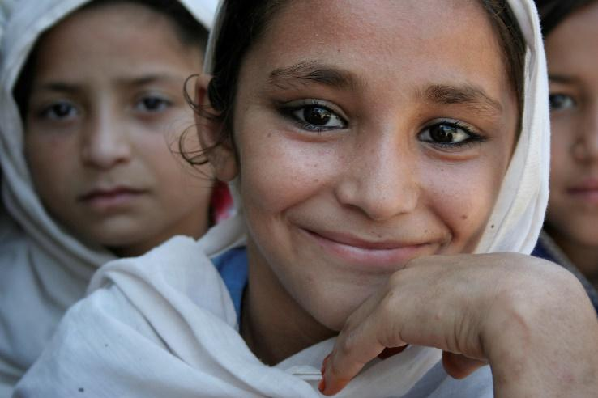We are a dynamic team, with ambitious goals to apply behavioral science in order to reach more children and have an even greater impact on their lives.

**Projects**

CUBIC is seeking an early career graphic design intern to support our Design Associate. High quality design is a central part of CUBIC’s offering to clients and partners, and we seek to maintain these standards across everything we produce – from behavioral protypes to presentations and reports.

**Internship Objectives**

The intern will be integrated into the 13-person CUBIC team and will have the opportunity to get involved in multiple projects – the expectation for the intern is that s/he would primarily contribute to:

1. Project summary presentations
2. Business development pitches/ proposals
3. Communications product design
4. Social media post design
5. Proofreading final design output where required

**Skills Required**

* Enrolled in/or recent graduate of design qualification/ early career in design and communication
* Interest and experience in using design for charity communications or social enterprise
* Experience of developing communication products
* Experience with Adobe (Illustrator, InDesign, Photoshop) and Microsoft packages (specifically PowerPoint) content marketing strategies
* Excellent written communication skills (English language)
* Strong collaboration and teamwork skills
* Animation skills are desirable

**Time Requirements**

**Part time internship** – appropriate for students/recent graduates. Expectation is for 8-12 hours a week, for a minimum of 6 months.

**Supervisor**

CUBIC’s Design Associate as well as other team members

**Conditions**

The intern would be engaged on a voluntary basis (non-paid) and would sign a volunteer contract with Save the Children. The working schedule would be determined by the intern; however, attendance during regular team calls and calls with our country partner teams would be important.

**Location**

Remote/home-based, time zone up to GMT +/- 6hrs